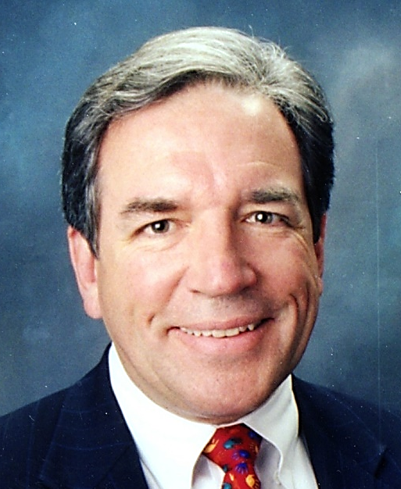
William O. Reed Jr., MD MBA
Founder, IATRICORP LLC
  - Dr. Reed has focused his entire career on helping individual patients and also assisting hospitals that are facing financial and operational challenges.
Dr. Reed completed his Orthopaedic Surgery training at Duke Medical Center and has an MBA from the Olin Business School at Washington University in St. Louis and Fudan University in Shanghai. He brings a wealth of knowledge and experience in the healthcare sector and is a valuable contributor politically and operationally to the hospital sector.
Dr. Reed shares he has a 30+ year career as a Physician-Executive and has focused on cutting edge surgical care for individual patients, as well as contributing to the need for more cost-effective and proficient care in hospitals.

Dr. Reed explained, “I’m focusing my efforts on successfully changing the course of challenged community hospitals and systems facing the uncertainty in today’s business environment that all too often results in reaching a financial precipice, resulting in closures and consolidation of hospitals, which is not necessarily in the best interest of the communities they serve.”

Dr. Reed is passionate about helping rural hospitals and their patients, and is looking forward to personally connecting with hospital executives to explore how he and IATRIX can assist with their hospitals financial stability. Dr. Reed said, ”I see IATRIX as a valuable solution for rural hospitals that are experiencing cash flow or financial difficulty and I’m enthusiastically offering solutions that can place rural, community and urban hospitals on solid financial foundations for their future. Additionally, the Big Data Management and Actionable Data Insight provided by IATRICOMP brings the power of predictive analytics to hospital financial and quality analyses resulting in dramatic improvements in fiscal efficiency and quality measures.”

Facilitating and assisting the hospital leadership to focus on improving community patient access and care is the ultimate goal and reward for Dr. Reed, as well as the rest of the IATRICORP team.

James M. Full, MSW, MBA, FACHE
Chief Operating Officer

Mr. Full is a seasoned healthcare executive with over 30 years of experience as a Chief Executive Officer for mid-size and rural hospitals (both free standing and/or affiliated with health systems), lead executive for a 22-hospital health system, CEO for a behavioral health hospital, and department administrator at a mid-west medical school.

Jim has been utilized by numerous organizations as a resource for his expertise in strategic planning, new program development, patient centered care initiatives, critical access hospital (CAH) designation, rural health clinic development and turn-around strategies.

Jim has been the recipient of the 3M/Healthcare Forum Innovator Award, the VA Innovative Management Award, and a Rural Health Leadership Award. He was also recognized with the “Regent Award” and the “Service Award” from the American College of Healthcare Executives for his contributions to the field. The American Hospital Association cited one of his hospitals as a case example on Workforce Retention/Recruitment Strategies. Jim was honored as the recipient of the “Rural Health Award for Community Service at the National Level” from the Indiana Rural Health Association.

Mr. Full is a graduate of Marquette University. He also received his Master’s Degree in Social Work from George Williams College and his Master’s Degree in Business Administration from DePaul University.

Tapan Bhatt, MBA
Chief Analytics Officer

Offering a unique blend of leadership, technology experience and business acumen, Tapan has over 18 years of experience in developing cutting-edge technology products and facilitating growth in start-up ventures. He has worked on both the coasts with a number of successful venture capital backed high-tech startups in leadership roles and as an equity partner. Tapan sits on the innovation board of Saint Luke’s Hospital System as well as on the advisory board of Avila University.
Tapan founded TeraCrunch with a vision of helping healthcare enterprises make data-backed decisions, by offering tailored analytics solutions that provide an order of magnitude better results over all other options. As Founder and CEO of TeraCrunch, Tapan is responsible for the company's strategic direction, growth and building the best data science organization in the world.
TeraCrunch works with payers, providers, pharma, equipment firms and other entities in the healthcare eco-system. TeraCrunch offers advanced analytics and artificial intelligent solutions to support Revenue Cycle Management, Patient Experience Management, Clinical Optimization, AI Drug Discovery, Population Health, Spur Innovation & Research and Proof of concept development.
TeraCrunch has one of best teams of PhD Data Scientists in world from Harvard, NASA and top commercial firms. Tapan has earned an MBA in Marketing from Avila University and has done Electrical Engineering from K.K.Wagh College of Engineering. He is a passionate tennis & soccer player, where he continues to learn hard work, self-denial, dedication, sacrifice and team play.
www.TeraCrunch.com

